**PRACTICAL – 1 (1.1)**

**AIM:**

|  |
| --- |
| **Create a program that asks the user to enter their name and their age. Printout a message addressed to them that tells them the year that they will turn 100 years old.** |

**PROGRAM:**

|  |
| --- |
| import datetime  name = input("Enter your Name: ")  age = int(input("Enter your Age: "))  date = datetime.datetime.now()  temp = 100 - age  update = temp + date.year  print(update)  print("\n20DCE019 - Yatharth Chauhan") |

**OUTPUT:**

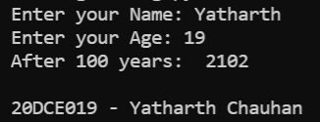

**CONCLUSION:**

**PRACTICAL – 1 (1.2)**

**AIM:**

|  |
| --- |
| **Write a program to ask the user for a number. Depending on whether the number is even or odd, print out an appropriate message to the user. Hint: how does an even / odd number react differently when divided by 2?** |

**PROGRAM:**

|  |
| --- |
| n = int(input("Enter Number: "))  if(n % 2 == 0):  print("Number is Even")  else:  print("Number is Odd")  print("\n20DCE019 - Yatharth Chauhan") |

**OUTPUT:**

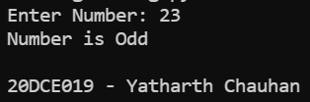

**CONCLUSION:**

**PRACTICAL – 2 (2.1)**

**AIM:**

|  |  |
| --- | --- |
| |  | | --- | | **Write a program as mentioned below:**  **Take a list, a = [1, 1, 2, 3, 5, 8, 13, 21, 34, 55, 89], and write a program that print out all the elements of the list that are less than 5.** | |

**PROGRAM:**

|  |
| --- |
| list = [1, 1, 2, 3, 5, 8, 13, 21, 34, 55, 89]  for i in range(len(list)):  if(list[i] < 5):    print(list[i], end=" ")  print("\n20DCE019 - Yatharth Chauhan") |

**OUTPUT:**

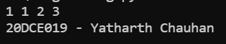

**CONCLUSION:**

**PRACTICAL – 2 (2.2)**

**AIM:**

|  |
| --- |
| **Create a program that asks the user for a number and then prints out a list of all the divisors of that number. (If you don’t know what a divisor is, it is a number that divides evenly into another number. For example, 13 is a divisor of 26 because 26 / 13 has no remainder.)** |

|  |
| --- |
|  |

**PROGRAM:**

|  |
| --- |
| n = int(input("Enter the Number: "))  print("The divisors of the number are:")  for i in range(1, n + 1):  if(n % i == 0):  print(i)  print("\n20DCE019 - Yatharth Chauhan") |

**OUTPUT:**

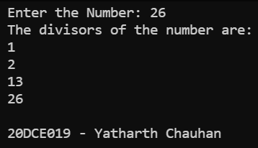

**CONCLUSION:**

**PRACTICAL – 3 (3.1)**

**AIM:**

|  |
| --- |
|  |

**PROGRAM:**

|  |
| --- |
|  |

**OUTPUT:**

**CONCLUSION:**

**PRACTICAL - 2**

**AIM:**

|  |
| --- |
|  |

**PROGRAM:**

|  |
| --- |
|  |

**OUTPUT:**

**CONCLUSION:**

**PRACTICAL - 2**

**AIM:**

|  |
| --- |
|  |

**PROGRAM:**

|  |
| --- |
|  |

**OUTPUT:**

**CONCLUSION:**

**PRACTICAL - 2**

**AIM:**

|  |
| --- |
|  |

**PROGRAM:**

|  |
| --- |
|  |

**OUTPUT:**

**CONCLUSION:**

**PRACTICAL - 2**

**AIM:**

|  |
| --- |
|  |

**PROGRAM:**

|  |
| --- |
|  |

**OUTPUT:**

**CONCLUSION:**

**PRACTICAL - 2**

**AIM:**

|  |
| --- |
|  |

**PROGRAM:**

|  |
| --- |
|  |

**OUTPUT:**

**CONCLUSION:**

**PRACTICAL - 2**

**AIM:**

|  |
| --- |
|  |

**PROGRAM:**

|  |
| --- |
|  |

**OUTPUT:**

**CONCLUSION:**

**PRACTICAL - 2**

**AIM:**

|  |
| --- |
|  |

**PROGRAM:**

|  |
| --- |
|  |

**OUTPUT:**

**CONCLUSION:**

**PRACTICAL - 2**

**AIM:**

|  |
| --- |
|  |

**PROGRAM:**

|  |
| --- |
|  |

**OUTPUT:**

**CONCLUSION:**

**PRACTICAL - 2**

**AIM:**

|  |
| --- |
|  |

**PROGRAM:**

|  |
| --- |
|  |

**OUTPUT:**

**CONCLUSION:**

**PRACTICAL - 2**

**AIM:**

|  |
| --- |
|  |

**PROGRAM:**

|  |
| --- |
|  |

**OUTPUT:**

**CONCLUSION:**

**PRACTICAL - 2**

**AIM:**

|  |
| --- |
|  |

**PROGRAM:**

|  |
| --- |
|  |

**OUTPUT:**

**CONCLUSION:**